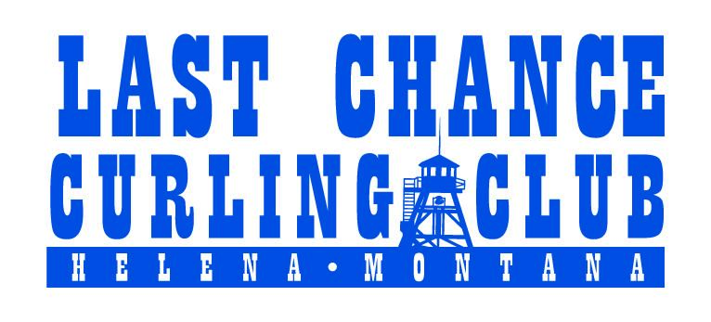

The Last Chance Curling Club (LCCC) invites you to join our Board of Directors. The LCCC Board of Directors consists of 9 members with terms of 2 years. This year we have 4 spots on the board that are up for election/re-election. The LCCC board meets monthly and has several committees that board members are encouraged to lead or join.

If you are interested in joining the LCCC Board of Directors, please tell us a little about yourself and why you are interested in joining the board. Complete the nomination form below and submit it back to the LCCC Secretary at [lastchancecurlingclub@gmail.com](mailto:lastchancecurlingclub@gmail.com) no later than Wednesday, August 27th.

This year's annual meeting is Wednesday, September 10th, 5:30pm at Montago Coffee Company (317 Cruse Ave, Helena). We will elect members to the Board of Directors for the 2025-2027 term. If you have any questions regarding the nomination and election process or board member duties, please contact us at [lastchancecurlingclub@gmail.com](mailto:lastchancecurlingclub@gmail.com).

Contact information:

Name -

Phone # -

Email -

I am interested in joining the Last Chance Curling Club Board because….

*The Last Chance Curling Club’s purpose is to promote the sport of curling in the Helena community through education, outreach, and by providing a safe, fun, inclusive, and friendly environment to foster public participation in the sport.*